**Chapter 3 – EXPRESS API EVENTS FUNCTIONALITY**

In the previous tutorial , we finish all events functionalities and it is integration between users advance and the actions . This means in this upcoming tutorial we will create three new controllers i.e., **ApprovalController , RegistrationController and RejectionController** . So, basically we have three endpoints that is one for approving, second is for registering and third is for rejection.

Now, we create new entity because we have users and an event and we need something to bind them. So, in **models folder** we create new file **“Registration.js”**. In this file, we used to create new registration for an events.

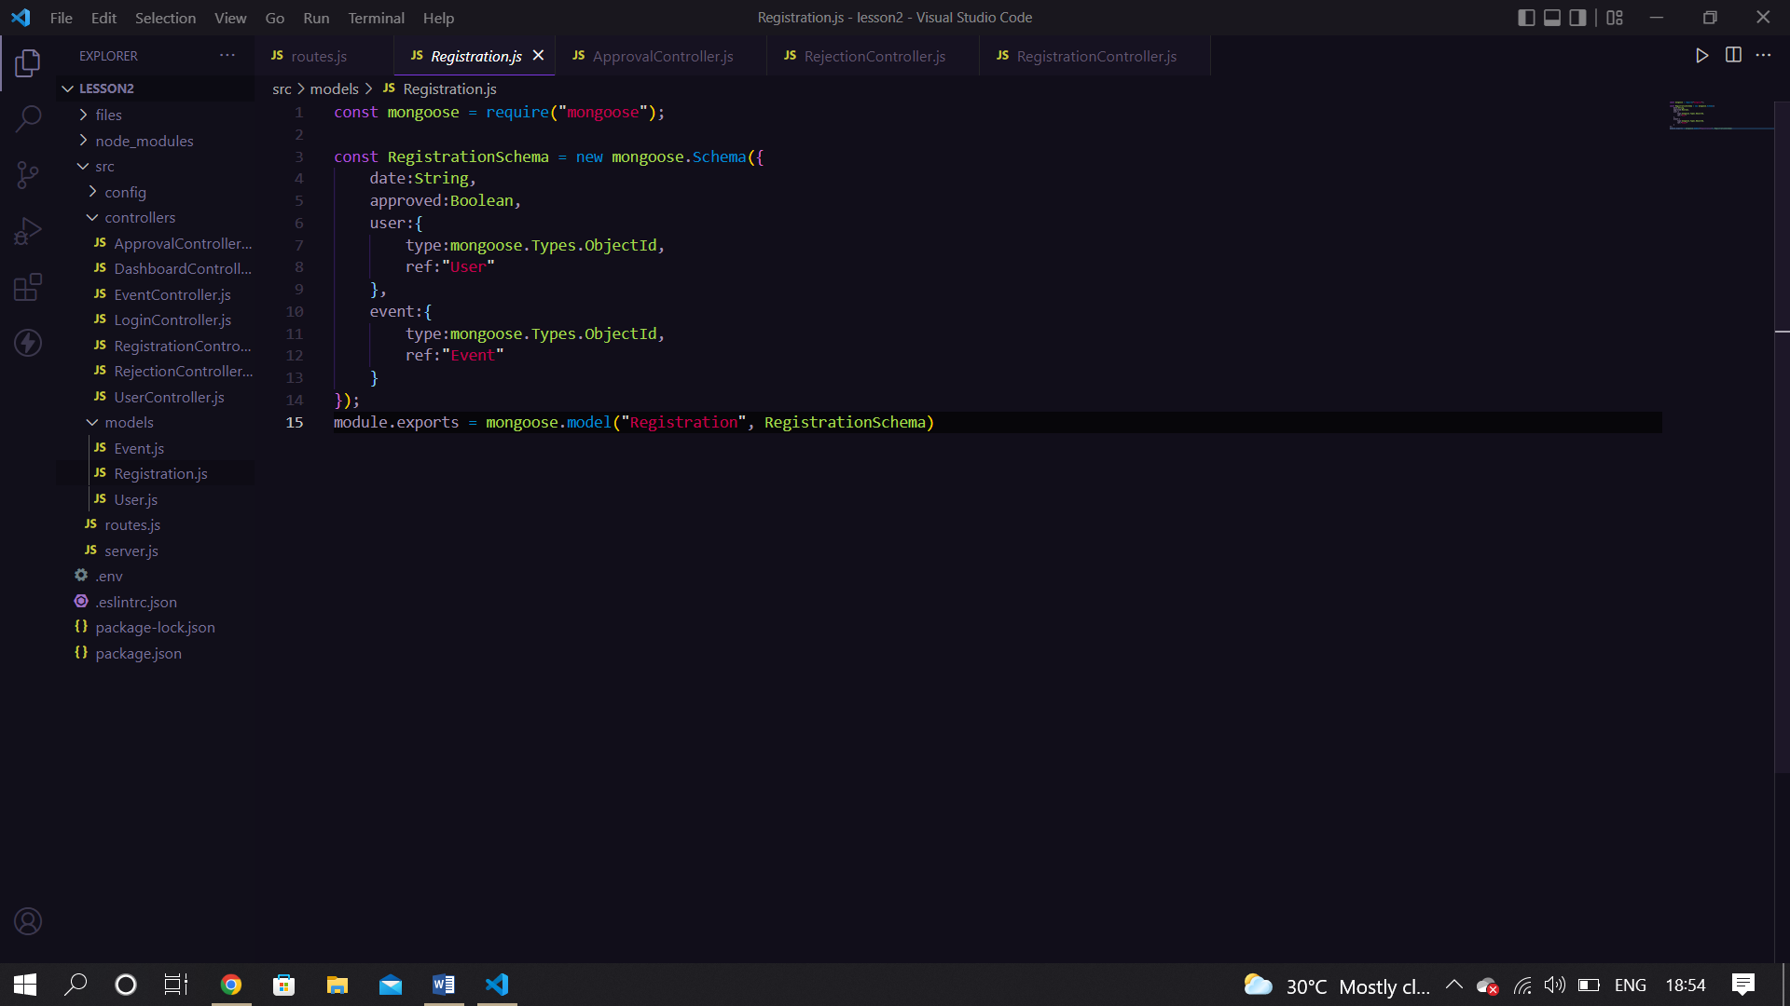

In **controllers** folder , we made another file called **“RegistrationController.js”.**

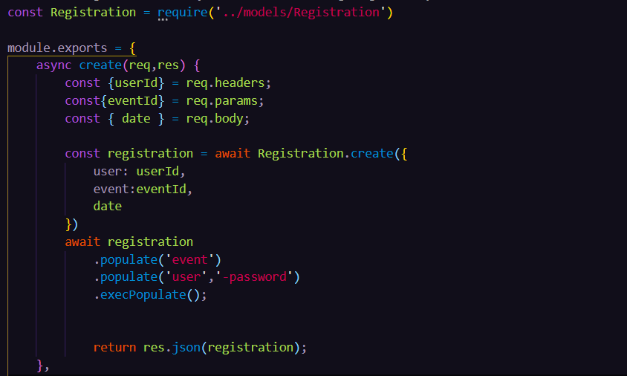

With the help of **create method()**, we are inserting an **user_id , eventId and date** . Date property is used for knowing on which date we are to register an event .

In **routes.js** file, we add routing for registration controller to create registration.



* populate( ) , which **lets you reference documents in other collections**. Population is the process of automatically replacing the specified paths in the document with document(s) from other collection(s).

In same file add another method called **“getRegistrationById( )” .** Add below code

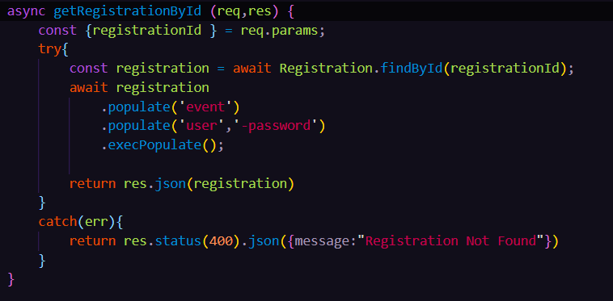

We are trying to find out **registrationId** from database from **findById method( ) .** If we do not find registration Id ,it will display you an error message .



We made another file in **controllers** folder and that will be **“ApprovalController.js”** .

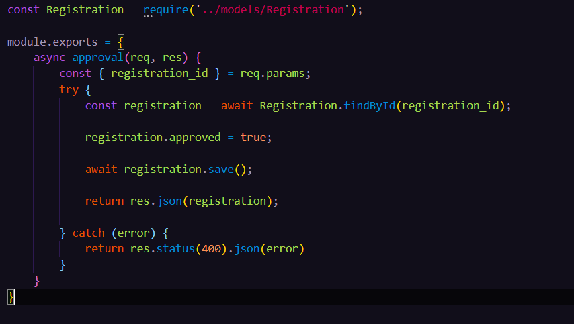

Now make another controller file and that is **“RejectionController.js”** file .

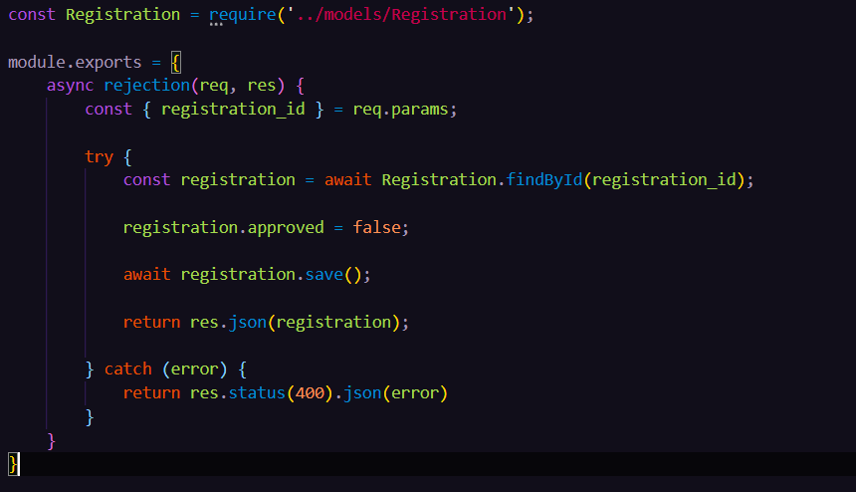

In **routes.js file** add below code for routing **ApprovalController** and **RejectionController** files.

const ApprovalController = require('./controllers/ApprovalController')

const RejectionController = require('./controllers/RejectionController')

routes.post('/registration/:registration_id/approvals', ApprovalController.approval)

routes.post ('/registration/:registration_id/rejections', RejectionController.rejection)